Image | 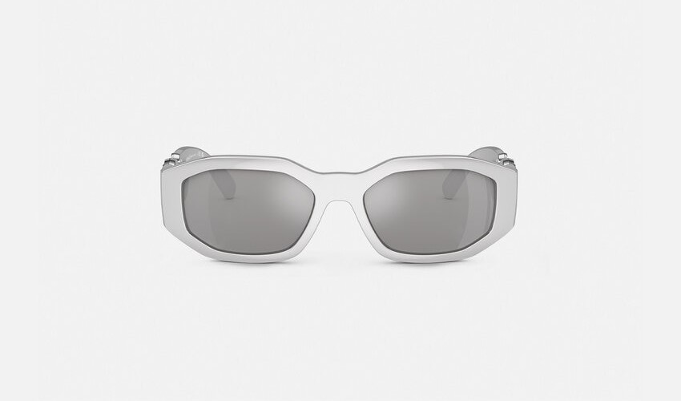
Brand | TOM FORD
Model Name | MEDUSA BIGGIE CHROME SUNGLASSES
Price | RS 245,00
PRODUCT DETAILS

